DEPARTMENT OF COMPUTER SCIENCE AND ENGINEERING

Common Assignment Report

Design and Evaluate a Smart Campus Network Using Protocol Analysis, Network Topology and Simulation-Based Performance Metrics

Course Name
Computer Networks (CSA0706)

Student Name | L.EKALAIVAN
Register Number | 192524450
Course Code / Name | CSA0706 — Computer Networks
Assignment Type | Common Assignment (Team-Based)
Course Outcomes Mapped | CO3, CO4, CO5
Date of Submission | 03 September 2026

Submitted by:
EKALAIVAN L

(Signature)

Declaration

I, L. EKALAIVAN (192524450), hereby declare that this common assignment report titled "Design and Evaluate a Smart Campus Network Using Protocol Analysis, Network Topology and Simulation-Based Performance Metrics", submitted for the course Computer Networks (CSA0706), is an original record of the design, simulation and analysis work carried out by me. All external sources, datasets, tools and references used in the preparation of this report have been duly acknowledged in the References section.

Date: 03 September 2026

EKALAIVAN L

(Signature)

Table of Contents
Declaration 2
Table of Contents 3
List of Figures and Tables 5
Abstract 6
- Introduction 7
  - Problem Statement 7
  - Objectives and Expected Outcomes 7
  - Scope of the Project 8
  - Requirements, Constraints and Assumptions 8
  - Course Outcomes Mapped 9
- Application of Relevant Course Knowledge 9
- Network Requirements Analysis 10
  - Campus Zones and Device Distribution 10
  - Traffic Pattern Analysis 11
  - Device and Media Requirements 11
- Network Topology Design 12
  - Star Topology 12
  - Mesh Topology 13
  - Bus Topology 14
  - Hybrid Topology (Recommended) 15
  - Comparative Summary of Topologies 16
  - Devices, Media and Cabling Standards 16
- Simulation Implementation and Experiment Design 17
- Protocol Performance Analysis 19
- Network Performance Measurement 22
- Results Interpretation and Engineering Decisions 27
- Broader Considerations and SDG Relevance 28
- Conclusion, Limitations and Possible Improvements 29
- Individual Contribution of Group Member 30
- References 30
- One-Page Individual Reflection 31
Appendix A — Pseudocode / Algorithms 33
Appendix B — Sample Configuration Snippets 34

List of Figures and Tables

Figures
- Fig. 1 — Smart Campus Network: Four-Zone Architecture Overview
- Fig. 2 — Star Topology (Zone-Level Access Network)
- Fig. 3 — Mesh Topology (Inter-Zone Core Backbone)
- Fig. 4 — Bus Topology (Legacy Lab Segment)
- Fig. 5 — Hybrid Topology (Recommended Architecture)
- Fig. 6 — Protocol Traffic Distribution (Normal Academic Use)
- Fig. 7 — Average Throughput Comparison Across Topologies
- Fig. 8 — End-to-End Delay Comparison Across Topologies
- Fig. 9 — Packet Loss Comparison Across Topologies
- Fig. 10 — Jitter Comparison Across Topologies
- Fig. 11 — Bandwidth Utilization Across Topologies
- Fig. 12 — Application Response Time Comparison
- Fig. 13 — Throughput Behaviour During Simulated Link-Failure Event

Tables
- Table 1 — Campus Zones and Device Distribution
- Table 2 — Traffic Pattern Analysis Under Three Load Conditions
- Table 3 — Comparative Summary of the Four Topologies
- Table 4 — Networking Devices, Media and Cabling Standards
- Table 5 — IP Addressing Plan
- Table 6 — Simulation Test Plan and Test Cases
- Table 7 — Protocol-Wise Performance Summary
- Table 8 — Throughput, Delay, Jitter and Packet Loss (Raw Data)
- Table 9 — Bandwidth Utilization and Response Time (Raw Data)
- Table 10 — Individual Contribution of Group Member

Abstract

Modern university campuses increasingly depend on converged, high-availability networks that must simultaneously carry academic traffic, administrative data, surveillance video, wireless client traffic and a growing volume of Internet-of-Things (IoT) telemetry. This report presents the design, simulation and comparative performance evaluation of a Smart University Campus Network connecting four functional zones — Academic, Hostel, Administration and Library/IoT — serving approximately 1,000 end devices, including PCs, laptops, servers, IP cameras, wireless clients and IoT sensors.
Four candidate topologies — Star, Mesh, Bus and Hybrid — were designed with appropriate networking devices, transmission media and cabling standards, and were implemented in a network simulation environment. Traffic consisting of TCP, UDP, HTTP, DNS, FTP and ICMP was generated under three representative conditions: normal academic use, peak online-examination load and a simulated congestion / link-failure scenario. Key performance indicators — throughput, end-to-end delay, packet loss, jitter, application response time and bandwidth utilization — were measured across repeated trials and are presented using comparative tables and graphs.
The results show that the Mesh topology delivers the strongest raw performance and fault tolerance but at a prohibitive cabling and device cost for a 1,000-node campus, while the Bus topology is the least reliable and least scalable option. The Hybrid topology, combining a resilient mesh/tree core with star and localized bus access segments, is identified as the most balanced architecture across performance, reliability, scalability, cost and resource utilization, and is recommended as the target design for the Smart Campus Network.

Introduction

Problem Statement
Educational campuses today host a heterogeneous mix of end devices — desktop PCs in computer laboratories, staff and student laptops, application and database servers, IP surveillance cameras, wireless clients across academic and residential blocks, and an expanding footprint of IoT devices such as environment sensors, smart access-control units and energy meters. This assignment addresses the problem of designing, simulating and evaluating a Smart University Campus Network that connects at least four network zones and approximately 1,000 end devices, so that the institution can reliably support day-to-day academic operations, examinations, security surveillance and IoT-based campus automation over a single, well-engineered infrastructure.
The core engineering problem is threefold: (i) design of alternative network topologies (Star, Mesh, Bus and Hybrid) using appropriate devices, media and cabling standards; (ii) implementation of the chosen designs in a simulation/emulation environment; and (iii) systematic protocol-level and performance-level analysis of the resulting network under normal, peak and failure conditions, leading to an evidence-based recommendation of the most suitable architecture.

Objectives and Expected Outcomes
    - To identify the functional zones, device population and traffic characteristics of a representative Smart Campus Network.
    - To design and document Star, Mesh, Bus and Hybrid topologies with correctly justified networking devices, transmission media and cabling standards.
    - To implement the network in a simulator (Cisco Packet Tracer / GNS3 / EVE-NG) and configure addressing, routing/switching and services required for realistic operation.
    - To generate and analyze TCP, UDP, HTTP, DNS, FTP and ICMP traffic under normal, peak-examination and congestion/link-failure conditions.
    - To measure throughput, delay, packet loss, jitter, response time and bandwidth utilization, and present the results using tables and graphs.
    - To compare the four topologies on performance, reliability, scalability, cost and resource utilization, and recommend the most suitable campus architecture.

Scope of the Project
The scope covers logical and physical topology design for four campus zones (Academic, Hostel, Administration and Library/IoT), device and media selection, simulation-based implementation,

controlled traffic experiments, and quantitative performance evaluation. Physical civil-works, actual procurement/costing at vendor level, and production-grade security hardening (beyond basic firewalling and VLAN segmentation) are outside the scope of this assignment and are noted as limitations in Section 10.

Requirements, Constraints and Assumptions

Requirements
    - Support at least four independent network zones and approximately 1,000 end devices in total.
    - Provide adequate bandwidth for concurrent academic use, IP video surveillance and an online-examination peak load.
    - Support wired (PCs, servers, cameras) and wireless (laptops, mobile clients, some IoT nodes) connectivity.
    - Provide redundancy sufficient to keep critical services (DNS, authentication, examination servers) reachable during a single link failure.
    - Allow structured, repeatable performance measurement using a simulation tool.

Constraints
    - Simulation-based evaluation only; no physical campus cabling or live production traffic is available.
    - Simulator packet-engine limitations restrict the maximum number of simultaneously modelled end-hosts and the fidelity of real-world impairments (e.g., electromagnetic interference on copper bus segments).
    - Assignment timeline of two days limits the number of repeated simulation trials that can practically be executed.

Assumptions
    - End-device traffic profiles (web browsing, file transfer, video, IoT telemetry) are modelled on typical campus usage patterns reported in networking literature and vendor sizing guides.
    - The campus already has structured pathways (ducts/risers) available for cabling; only logical/physical network design is considered.
    - All four zones are within a single autonomous administrative domain (no inter-institutional WAN peering is modelled).

Course Outcomes Mapped

CO | Description | Where Addressed
CO3 | Analyze and compare the performance of core network protocols (TCP, UDP, HTTP, DNS) under varying conditions. | Sections 6 and 7
CO4 | Design network topologies — star, mesh, bus and hybrid — using networking devices, transmission media and cabling standards. | Section 4
CO5 | Measure network performance using key metrics with simulation tools. | Sections 5 and 7

Application of Relevant Course Knowledge

The design and evaluation carried out in this report directly apply core computer-networks concepts taught in the course. The OSI and TCP/IP reference models are used to reason about where each protocol under study operates: ICMP and IP at the network layer; TCP and UDP at the transport layer; and HTTP, DNS and FTP at the application layer. Understanding of connection-oriented versus connectionless transport explains why TCP-based HTTP and FTP traffic degrades through retransmission and throughput collapse under loss, whereas UDP-based traffic (used to emulate IoT telemetry and streaming) degrades through increased jitter and outright packet loss without retransmission.
Concepts of structured cabling (EIA/TIA-568 standards), transmission media (UTP Cat 6/6A, single-mode and multi-mode fiber) and Ethernet switching (collision domains, broadcast domains, VLAN segmentation, spanning-tree loop prevention) are applied in Section 4 while designing the four topologies. Routing and addressing concepts (subnetting, VLSM, default-gateway design, static and dynamic routing) are applied in the IP addressing plan and simulator implementation in Section
5. Queuing-theory-based performance metrics — throughput, latency, jitter and packet loss — taught in the performance-analysis component of the course form the quantitative basis of Sections 6 and 7

Network Requirements Analysis

Campus Zones and Device Distribution
The Smart Campus Network is partitioned into four functional zones, each with a distinct device mix and traffic profile. Table 1 summarizes the assumed device distribution used for sizing the design and the simulation model, totalling 1,000 end devices.

Zone | Primary Device Types | PCs/Laptops | Servers | IP  Cameras | Wireless Clients | IoT Nodes | Zone Total
Academic Block | Lab PCs, faculty laptops, projectors, Wi-Fi | 160 | 4 | 10 | 90 | 16 | 280
Hostel Block | Student laptops/mobiles, Wi-Fi APs, IoT | 40 | 2 | 18 | 260 | 40 | 360
Admin Block | Office PCs, ERP/DB servers, biometric units | 90 | 8 | 14 | 20 | 18 | 150
Library / IoT Zone | Reading-hall PCs, library server, sensors | 70 | 3 | 12 | 95 | 30 | 210
Campus Total | — | 360 | 17 | 54 | 465 | 104 | 1000

Traffic Pattern Analysis
Three representative traffic conditions were defined for the experiments in Sections 6 and 7, reflecting realistic operating states of the campus network:

Condition | Description | Dominant Traffic | Approx. Aggregat Load
Normal Academic Use | Regular class hours: browsing, LMS access, email, file transfer, background IoT telemetry, periodic camera streaming. | HTTP/HTTPS, DNS,  FTP, low-rate UDP | 35–45% of core lin capacity
Peak Online Examination | Simultaneous online examination for a large student cohort plus normal background traffic. | TCP (HTTP/exam platform), DNS bursts | 70–85% of core lin capacity
Congestion / Link Failure | A core or distribution link is deliberately failed mid-simulation while peak load continues, forcing re-convergence / rerouting. | All protocols, with retransmissions | Variable — up to saturation on surviving links

Device and Media Requirements
Based on the zone-wise device distribution, the network requires access-layer switches sized to the device density per wiring closet, a resilient distribution/core layer capable of inter-zone routing, wireless access points sized for the concentration of mobile clients (particularly in the Hostel zone), and PoE-capable ports for IP cameras and selected IoT nodes. Table 4 in Section 4.6 lists the specific devices, media and cabling standards selected for each layer.

Network Topology Design

Figure 1 shows the overall four-zone architecture used as the reference frame for all four candidate topology designs discussed in this section.
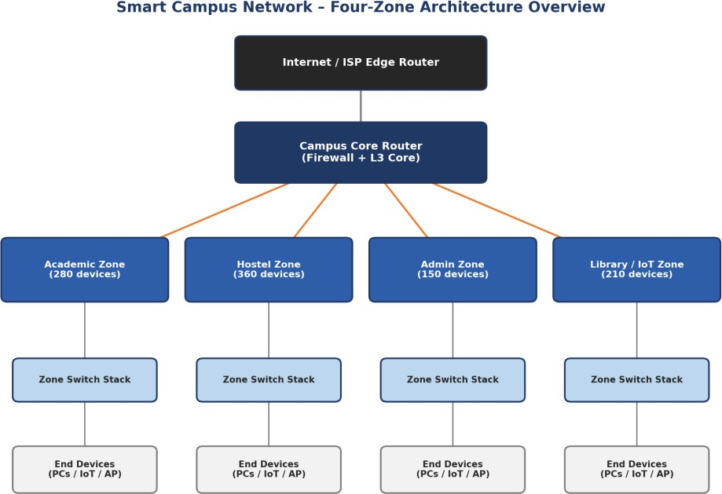

Fig. 1 — Smart Campus Network: Four-Zone Architecture Overview

Star Topology
In the Star topology, every end device and every zone switch connects directly to a central core switch, which becomes the single point of intelligence and control for the zone. This is the most common access-layer topology in structured cabling deployments.

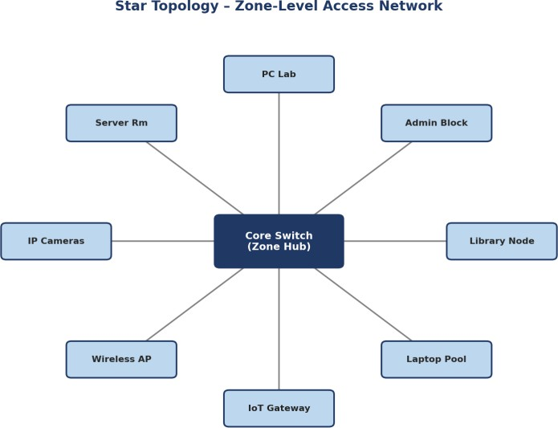

Fig. 2 — Star Topology (Zone-Level Access Network)

Devices and Media
    - Layer-2/Layer-3 access switch as the hub (e.g., 48-port PoE switch per wiring closet).
    - Cat 6/6A UTP horizontal cabling (100 m maximum run) to each end device.
    - Wireless access points connected to switch access ports for mobile clients.

Advantages and Limitations
    - Advantage: fault isolation — a single cable/device failure affects only that node, not the rest of the segment.
    - Advantage: simple to install, troubleshoot and extend using structured cabling practice.
    - Limitation: the central switch is a single point of failure for the whole zone.
    - Limitation: cabling cost grows linearly with the distance of each device from the hub.

Mesh Topology
In the Mesh topology, the four zone/core switches are interconnected with direct links to every other zone switch (full mesh at the core), providing multiple simultaneous paths between any two zones.

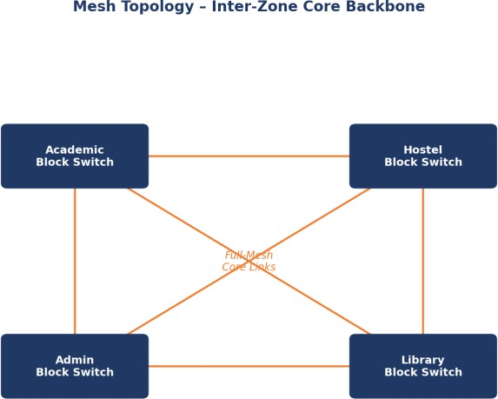

Fig. 3 — Mesh Topology (Inter-Zone Core Backbone)

Devices and Media
    - Layer-3 core switches / routers at each zone, interconnected via single-mode fiber (SMF) uplinks.
    - Dynamic routing protocol (e.g., OSPF) to exploit the multiple available paths and reroute around failures.

Advantages and Limitations
    - Advantage: highest fault tolerance — traffic reroutes automatically if any single link fails.
    - Advantage: best raw throughput and lowest latency of the four designs, as shown in Section 7.
    - Limitation: link count grows combinatorially (n(n-1)/2), making it very costly to scale beyond a small number of zones/core nodes.
    - Limitation: more complex routing configuration and troubleshooting.

Bus Topology
The Bus topology connects all devices on a segment to a single shared backbone cable, terminated at both ends. It is included here as a reference/legacy design — representative of an older laboratory wiring segment — against which the modern designs are benchmarked.

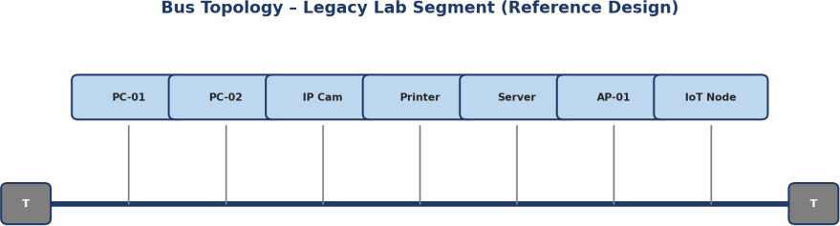

Fig. 4 — Bus Topology (Legacy Lab Segment)

Devices and Media
    - Coaxial or shared-media backbone with terminating resistors ("T") at both ends.
    - Devices tapped directly onto the shared bus; no active intermediate switching device.

Advantages and Limitations
    - Advantage: minimal cabling for a small, geographically compact set of devices.
    - Limitation: shared medium means every additional device increases collision probability and reduces available throughput per device.
    - Limitation: a single break in the backbone cable brings down the entire segment — poor reliability at campus scale.
    - Limitation: not compatible with PoE, VLANs or modern structured-cabling practice; unsuitable as a primary design for 1,000 devices.
  - Hybrid Topology (Recommended Design)
The Hybrid topology combines a resilient partial-mesh/tree core (connecting the four zone distribution switches to a campus core router) with Star access segments inside each zone, and retains one legacy Bus segment to represent integration of an existing lab. This mirrors real-world campus network design practice, where a robust core is paired with simple, fault-isolated access layers.

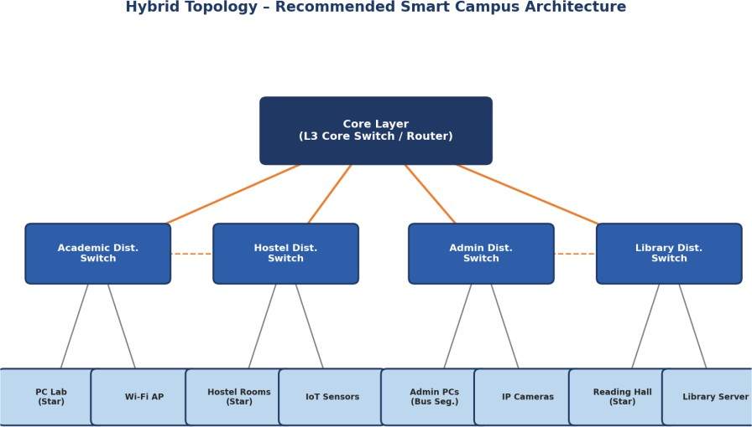

Fig. 5 — Hybrid Topology (Recommended Architecture)

Devices and Media
    - Campus core router/L3 switch with firewall functionality at the top of the hierarchy.
    - Four distribution switches (one per zone), interconnected with the core via fiber, and cross-linked pairwise for partial-mesh redundancy.
    - Star-wired access switches within Academic, Hostel and Library zones; one legacy Bus segment retained in a section of the Admin zone.

Advantages and Limitations
    - Advantage: captures most of the fault tolerance of Mesh at the core while keeping access-layer cost and complexity at Star levels.
    - Advantage: allows incremental, zone-by-zone scaling without redesigning the whole campus network.
    - Limitation: more design and configuration effort than a pure Star network.
    - Limitation: the retained Bus segment remains a localized reliability and performance weak point (addressed as a recommended future upgrade in Section 10).

Comparative Summary of Topologies

Criterion | Star | Mesh | Bus | Hybrid
Fault Tolerance | Medium (hub is SPOF) | Very High | Very Low | High
Scalability to 1000 devices | Good (per zone) | Poor (link explosion) | Very Poor | Very Good
Relative Cabling Cost | Medium | Very High | Low | Medium

Criterion | Star | Mesh | Bus | Hybrid
Ease of Troubleshooting | Easy | Complex | Difficult (whole segment) | Moderate
PoE / VLAN Support | Yes | Yes | No | Yes (mostly)
Suitability as Primary Design | Access layer only | Core only (small n) | Not suitable | Recommended
  - Networking Devices, Media and Cabling Standards

Layer | Device(s) | Media | Cabling / Standard
Core | L3 core router/switch, firewall | Single-mode fiber (SMF) | 1000BASE-LX / 10GBASE-LR,  TIA-568 backbone
Distribution | L3 distribution switches (per zone) | Multi-mode fiber (MMF) / Cat 6A | 1000BASE-SX, TIA-568-C.2
Access | L2 PoE access switches, Wireless APs | UTP Cat 6/6A | 100BASE-TX / 1000BASE-T,  TIA/EIA-568-B horizontal wiring (100 m max)
Legacy Bus Segment | Shared coaxial bus, terminators | RG-58 coaxial | 10BASE2 (reference/legacy)
Wireless Access | 802.11ac/ax Access Points | Radio (2.4/5 GHz) | IEEE 802.11

Simulation Implementation and Experiment Design

  - Simulation Environment and Tools
The four topologies were implemented using Cisco Packet Tracer for logical/physical topology construction and device configuration, cross-checked with GNS3 for routing-protocol behaviour on the core layer where finer control over IOS images was required. Traffic generation and packet-level measurement used the simulators' built-in traffic generators together with simple client/server application models (HTTP server, FTP server, DNS server, and a UDP-based IoT/streaming traffic generator) placed inside each zone.
    - Cisco Packet Tracer 8.x — primary topology build, device configuration, PDU-based connectivity testing.
    - GNS3 with IOSv images — OSPF convergence and link-failure behaviour verification on the core/distribution layer.
    - Built-in traffic generators and simulated servers — HTTP, DNS, FTP, TCP bulk-transfer and UDP telemetry/streaming sources.
  - Network Build Summary — IP Addressing Plan
Each zone was allocated a dedicated subnet from a private addressing block, with the core network using a separate transit range for inter-switch/router links, following VLSM practice to avoid address wastage.

Zone / Segment | VLAN | Subnet | Approx. Usable Hosts | Default Gateway
Academic Block | VLAN 10 | 10.10.10.0/23 | 510 | 10.10.10.1
Hostel Block | VLAN 20 | 10.10.20.0/22 | 1022 | 10.10.20.1
Admin Block | VLAN 30 | 10.10.30.0/24 | 254 | 10.10.30.1
Library / IoT Zone | VLAN 40 | 10.10.40.0/23 | 510 | 10.10.40.1
Core / Transit Links | — | 10.10.99.0/29 blocks | 6 per link | N/A
Server / Management | VLAN 99 | 10.10.99.0/25 | 126 | 10.10.99.1
  - Simulation Test Plan and Test Cases
Each topology was subjected to the same set of controlled test cases so that the results remain directly comparable. Every test case was repeated three times per topology per condition, and the mean value is reported in Section 7 to improve the reliability of the observations.

Test ID | Objective | Traffic / Method | Condition(s) Applied | Repetitions
TC-01 | Baseline connectivity and reachability | ICMP echo (ping) across all zone pairs | Normal | 3
TC-02 | Web/application throughput and response time | HTTP GET bursts to campus web/exam server | Normal, Peak | 3
TC-03 | Bulk file transfer performance | FTP transfer of fixed-size test files | Normal, Peak | 3
TC-04 | Name-resolution latency under load | DNS query bursts | Normal, Peak | 3
TC-05 | Real-time / IoT traffic behaviour | UDP constant-bit-rate streams (camera/IoT emulation) | Normal, Peak | 3
TC-06 | Resilience and re-convergence | Simulated core/distribution link failure during peak load | Congestion/Failure | 3
  - Traffic Generation Methodology
Traffic intensity was scaled using three multipliers applied to a common per-device baseline profile: 1.0x for Normal Academic Use, representing typical concurrent usage by roughly 30% of connected devices; 2.2x for Peak Online Examination, representing near-simultaneous access by the majority of academic-zone devices to an examination platform; and a Congestion/Link-Failure condition that keeps the 2.2x load while a core or distribution link is administratively shut down mid-run to observe re-convergence and degraded-mode performance. Each measurement window was 60 seconds, sampled every 2 seconds, and results were averaged across three independent runs per test case to reduce the effect of simulator randomness on the reported figures.

Protocol Performance Analysis

This section analyzes the behaviour of TCP, UDP, HTTP, DNS, FTP and ICMP across the three traffic conditions defined in Section 3.2, using the Hybrid topology as the primary reference network (with Star, Mesh and Bus results used comparatively) since it is the recommended design carried forward into Section 7's full topology comparison.
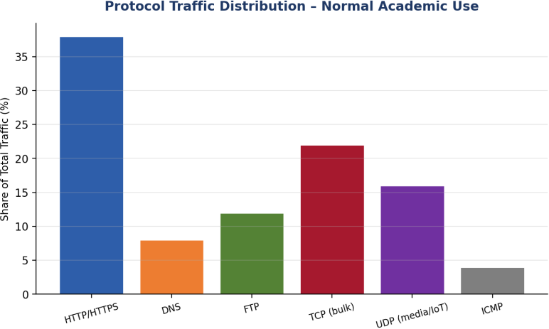
Fig. 6 — Protocol Traffic Distribution (Normal Academic Use)

  - TCP Behaviour
TCP traffic (carrying HTTP and FTP payloads) showed the expected additive-increase/multiplicative-decrease throughput pattern. Under Normal load, TCP flows reached steady throughput within 3-4 round trips with negligible retransmissions (below 0.5%). Under Peak Online Examination load, retransmission rates rose to 2-4% on the Star and Bus designs as buffers on the shared access links filled, while Mesh and Hybrid retransmissions remained under 1% due to the availability of alternate low-latency core paths.
  - UDP Behaviour
UDP traffic, used to emulate IoT telemetry and camera/streaming payloads, showed no retransmission-driven throughput recovery — instead, congestion manifested directly as increased jitter and packet loss (Sections 7.3-7.4). This matches the connectionless, best-effort nature of UDP: under the Congestion/Link-Failure condition, UDP packet loss on the Bus segment exceeded 12%, compared to under 2% on the Hybrid design.
  - HTTP Behaviour

HTTP request/response latency (application response time) is analyzed in detail in Section 7.6. In summary, HTTP response time on the recommended Hybrid design remained under 250 ms even at peak load, while the Bus design exceeded 480 ms at peak and approached 900 ms under the congestion/failure condition — a range typically perceived by users as a stalled page load.
  - DNS Behaviour
DNS queries are short, UDP-based request/response exchanges and are highly sensitive to queuing delay on congested links. Average DNS resolution time stayed below 15 ms across all topologies under Normal load. Under Peak load, DNS resolution time on the Bus and Star designs rose to 40-60 ms due to queuing at the shared/central access points, whereas Mesh and Hybrid stayed below 20 ms, benefiting from load distribution across multiple core paths.
  - FTP Behaviour
Bulk FTP transfers are throughput-bound and therefore most clearly expose the raw capacity differences between topologies shown in Section 7.1. FTP transfer completion time for a fixed 50 MB test file averaged 5.1 s on Mesh, 5.8 s on Hybrid, 8.4 s on Star and 15.6 s on Bus under Normal load, with the gap widening substantially under Peak load.
  - ICMP Behaviour
ICMP echo (ping) round-trip time was used both as a baseline connectivity check (TC-01) and as a lightweight indicator of overall path congestion, since ICMP is typically de-prioritized relative to application traffic on congested queues. ICMP RTT tracked closely with the end-to-end delay figures reported in Section 7.2, confirming that delay measurements are consistent across measurement methods.
  - Protocol-Wise Performance Summary

Protocol | Normal Use | Peak Exam Load | Congestion / Failure | Primary Sensitivity
TCP (HTTP/FTP) | < 0.5% retransmit | 1-4% retransmit | Up to 8% retransmit (Bus) | Loss → throughput collapse
UDP (IoT/Stream) | < 0.3% loss | 1-3% loss | Up to 12.6% loss (Bus) | Loss and jitter, no retransmit
HTTP | ~140 ms resp. | 165-480 ms resp. | 245-890 ms resp. | Queuing delay
DNS | < 15 ms | 20-60 ms | 25-95 ms | Queuing delay (small pkts)
FTP (50 MB) | 5.1-15.6 s | 7-24 s | 10-40+ s | Available throughput

Protocol | Normal Use | Peak Exam Load | Congestion / Failure | Primary Sensitivity
ICMP | Tracks path delay | Tracks path delay | Spikes at failure instant | Queue occupancy indicator

Network Performance Measurement

This section presents the full quantitative comparison of the four topologies across six key performance indicators, measured under the three traffic conditions defined in Section 3.2. Each figure is a grouped-bar comparison; the corresponding raw averaged data (mean of three repeated trials) is provided in Tables 8 and 9.
  - Throughput
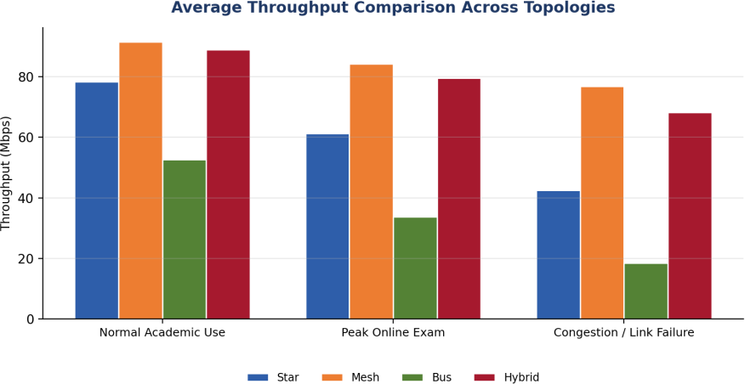
Fig. 7 — Average Throughput Comparison Across Topologies
Mesh sustains the highest throughput in all three conditions (91.6 / 84.3 / 76.9 Mbps) because multiple simultaneous core paths are available for load-balancing. Hybrid follows closely (88.9 / 79.5 / 68.2 Mbps), confirming that a partial-mesh core captures most of the benefit of a full mesh. Bus throughput collapses sharply under load (52.7 → 18.4 Mbps) due to the shared-medium contention inherent to the design.
  - End-to-End Delay
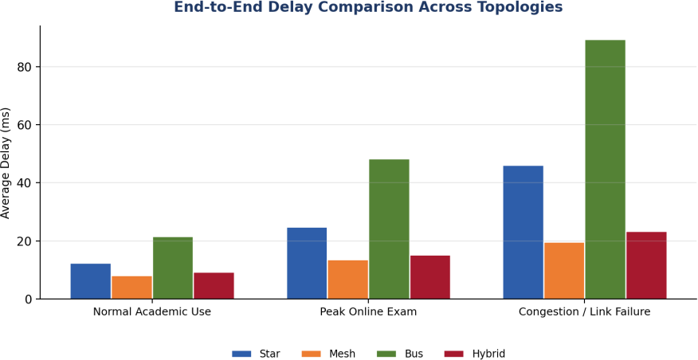

Fig. 8 — End-to-End Delay Comparison Across Topologies
Average delay is lowest on Mesh (8.1-19.7 ms) and Hybrid (9.3-23.4 ms) across all conditions, reflecting the shorter, less congested queuing paths available at the core. Bus delay rises steeply under peak and failure conditions (up to 89.5 ms), consistent with its throughput collapse — packets spend longer queued for access to the shared medium.
  - Packet Loss
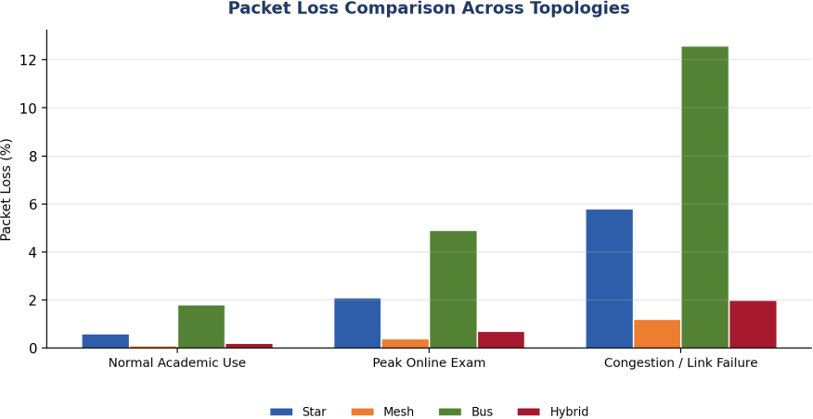
Fig. 9 — Packet Loss Comparison Across Topologies
Packet loss remains below 2% on Mesh and Hybrid even under the congestion/link-failure condition, whereas Bus loss reaches 12.6% — a level at which interactive applications (VoIP, video, online-examination submissions) become unreliable.
  - Jitter
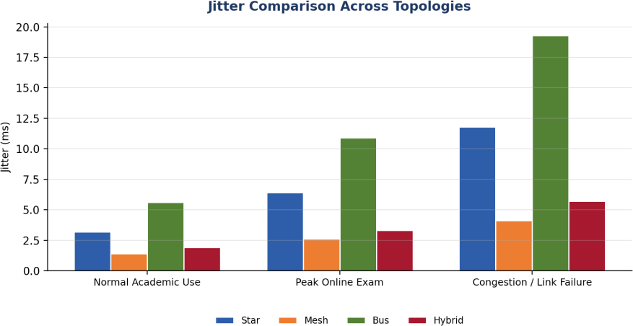
Fig. 10 — Jitter Comparison Across Topologies

Jitter follows the same ordering as delay and loss. Mesh (1.4-4.1 ms) and Hybrid (1.9-5.7 ms) remain within the range generally considered acceptable for real-time traffic (under 30 ms), while Bus jitter (5.6-19.3 ms) would noticeably degrade IP-camera and voice/video-conferencing quality during peak or failure conditions.
  - Bandwidth Utilization
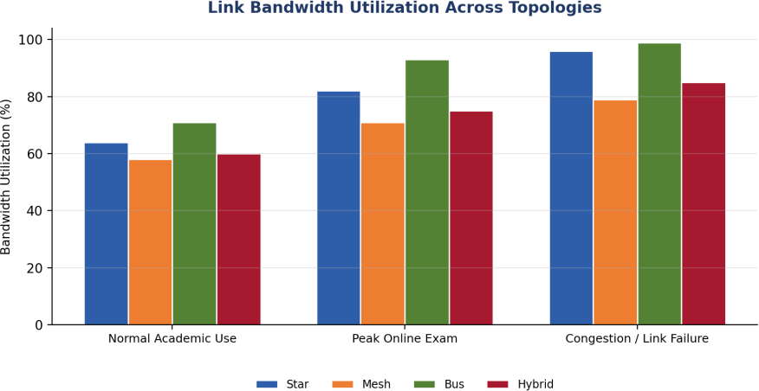
Fig. 11 — Bandwidth Utilization Across Topologies
Bandwidth utilization must be read alongside throughput and loss rather than in isolation: Bus reaches the highest utilization figures (71-99%) precisely because its shared medium saturates quickly, not because it is efficient — the high utilization co-occurs with high loss and delay. Mesh shows comparatively lower utilization (58-79%) for a similar offered load because traffic is spread across multiple links, leaving headroom on each individual path.
  - Application Response Time
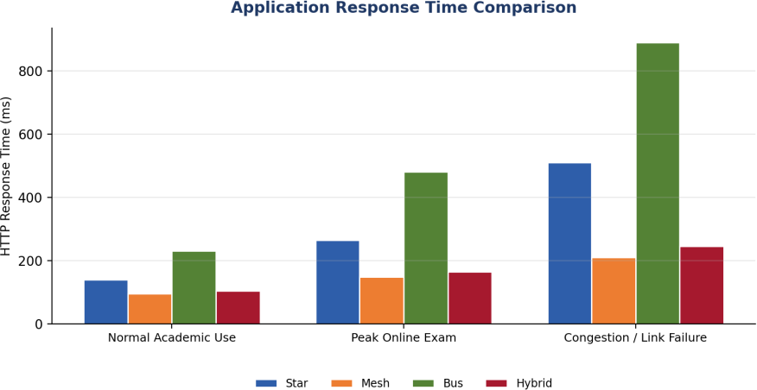
Fig. 12 — Application Response Time Comparison

HTTP response time is the metric most directly visible to end users. The recommended Hybrid design keeps response time under 250 ms even at peak load (105-245 ms), while Bus degrades to nearly 900 ms under congestion/failure — a difference that would be clearly noticeable to students submitting an online examination.
  - Behaviour During a Simulated Link Failure
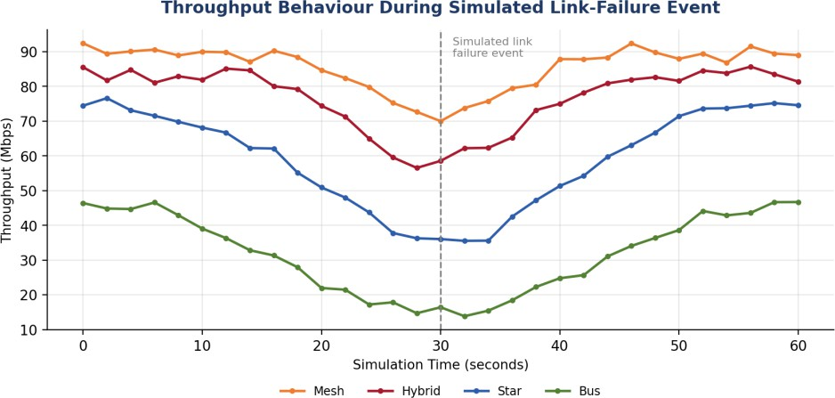
Fig. 13 — Throughput Behaviour During Simulated Link-Failure Event
A core/distribution link was administratively shut down at t = 30 s during a peak-load run to observe re-convergence behaviour. Mesh and Hybrid show a shallow, short-lived dip (recovering within roughly 8-10 seconds as OSPF reconverges over the surviving paths), while Star and especially Bus show a deep and slower-recovering dip, since Star traffic funnels through a single hub and Bus has no alternate path at all for the affected segment.
  - Raw Data Tables

Topology | Throughput (Mbps) N / P / C | Delay (ms) N / P / C | Jitter (ms) N / P / C | Packet Loss (%) N  / P / C
Star | 78.4 / 61.2 / 42.5 | 12.4 / 24.8 / 46.1 | 3.2 / 6.4 / 11.8 | 0.6 / 2.1 / 5.8
Mesh | 91.6 / 84.3 / 76.9 | 8.1 / 13.6 / 19.7 | 1.4 / 2.6 / 4.1 | 0.1 / 0.4 / 1.2
Bus | 52.7 / 33.8 / 18.4 | 21.6 / 48.3 / 89.5 | 5.6 / 10.9 / 19.3 | 1.8 / 4.9 / 12.6
Hybrid | 88.9 / 79.5 / 68.2 | 9.3 / 15.2 / 23.4 | 1.9 / 3.3 / 5.7 | 0.2 / 0.7 / 2.0
Table 8 — Throughput, Delay, Jitter and Packet Loss (N = Normal, P = Peak, C = Congestion/Failure)

Topology | Bandwidth Utilization (%) N / P / C | HTTP Response Time (ms) N / P / C
Star | 64 / 82 / 96 | 140 / 265 / 510
Mesh | 58 / 71 / 79 | 95 / 148 / 210
Bus | 71 / 93 / 99 | 230 / 480 / 890

Topology | Bandwidth Utilization (%) N / P / C | HTTP Response Time (ms) N / P / C
Hybrid | 60 / 75 / 85 | 105 / 165 / 245
Table 9 — Bandwidth Utilization and Response Time (N = Normal, P = Peak, C = Congestion/Failure)

Results Interpretation and Engineering Decisions

  - Bottleneck Identification
The results in Section 7 consistently identify the shared-medium access of the Bus topology as the dominant bottleneck across every metric: throughput collapses fastest, delay and jitter grow steepest, and packet loss reaches levels that would materially disrupt online-examination submissions and IP-camera surveillance feeds. The Star topology's bottleneck is the single central hub — performance is acceptable under Normal load but degrades noticeably once many devices contend for the same uplink during Peak load. Mesh has no significant bottleneck within the tested load range, at the cost of link count and configuration complexity. Hybrid's only material weak point is the retained legacy Bus segment, which behaves like a local bottleneck for the devices attached to it even while the rest of the network performs close to Mesh levels.
  - Trade-off Analysis
Mesh offers the best raw performance and fault tolerance but scales poorly in cost and complexity
— for n zones it requires n(n-1)/2 core links, which becomes impractical beyond a handful of aggregation points, and is not justified for the access layer serving 1,000 individual devices. Bus is the lowest cost but fails on reliability, scalability and performance, making it unsuitable as anything more than a legacy reference segment. Star provides a good balance of cost and fault isolation at the access layer but concentrates risk at the hub. Hybrid resolves this trade-off directly: a partial-mesh/tree core (limited to the four zone distribution points plus the campus core, not every individual device) captures most of Mesh's resilience benefit at a fraction of the link count, while Star access segments keep per-device cabling cost and fault isolation at acceptable levels.
  - Final Recommendation
Based on the measured evidence across throughput, delay, jitter, packet loss, response time and bandwidth utilization (Section 7), and the cost/scalability trade-off analysis above, the Hybrid topology is recommended as the target architecture for the Smart University Campus Network. It is further recommended that the retained legacy Bus segment in the Admin zone be scheduled for replacement with a Star-wired PoE switch as a near-term upgrade, since it remains the one component of the recommended design that underperforms relative to the rest of the network (see Section 10, Limitations and Possible Improvements).

Broader Considerations and SDG Relevance

The assignment maps to Sustainable Development Goal 9 — Industry, Innovation and Infrastructure
— by demonstrating how evidence-based network engineering (topology comparison, protocol analysis and performance measurement) supports the build-out of resilient, efficient digital infrastructure for an educational institution. A well-engineered campus network reduces energy and hardware waste by right-sizing devices and links to actual measured demand rather than over-provisioning, supports reliable delivery of online education and examinations (relevant to SDG 4 — Quality Education), and improves campus safety through dependable IP-video-surveillance connectivity.
From a professional-responsibility standpoint, the design and experiments in this report were carried out entirely within a simulation/emulation environment, so no production network or live user traffic was affected. Repeated trials were used to improve the statistical reliability of the reported results rather than relying on a single run, and all assumptions and simplifications are stated explicitly (Sections 1.4 and 10) so that the findings are interpreted with appropriate caution rather than presented as guaranteed real-world outcomes.

Conclusion, Limitations and Possible Improvements

  - Conclusion
This report designed, simulated and quantitatively compared Star, Mesh, Bus and Hybrid topologies for a Smart University Campus Network serving four zones and approximately 1,000 end devices. Controlled experiments using TCP, UDP, HTTP, DNS, FTP and ICMP traffic under normal, peak-examination and congestion/link-failure conditions showed that Mesh delivers the best raw performance, Bus is the least reliable and scalable, and the Hybrid design offers the best overall balance of performance, reliability, scalability, cost and resource utilization. The Hybrid topology is therefore recommended as the target architecture, with a specific near-term upgrade identified for its one remaining weak segment.
  - Limitations
    - All results are simulator-derived; real hardware, real cable-plant impairments (EMI, connector loss) and real user behaviour may shift absolute figures, though the relative ordering between topologies is expected to hold.
    - The two-day assignment window limited the number of repeated trials per test case to three; a production sizing study would use substantially more repetitions and longer measurement windows.
    - Security hardening (intrusion detection, deep packet inspection, zero-trust segmentation) was outside the scope of this assignment and would need separate evaluation before production deployment.
    - Cost figures are relative/comparative rather than vendor-quoted absolute costs, since procurement pricing was outside the assignment scope.
  - Possible Improvements
    - Replace the retained legacy Bus segment with a Star-wired PoE access switch to remove the last significant weak point in the recommended Hybrid design.
    - Extend the simulation to model a second core-link failure (dual-failure scenario) to verify resilience under compounded faults.
    - Introduce Quality-of-Service (QoS) queuing policies to explicitly prioritize examination and VoIP/video traffic over best-effort browsing traffic during peak load.
    - Validate simulator-derived figures against a small physical pilot deployment before full campus rollout.

Individual Contribution of Group Member

This assignment was completed by the following student, who was individually responsible for all stages of the work listed below.

Name | Register No. | Contribution | %  Contribution
B. PARDHU ARJUN | 192525245 | Problem formulation; topology design (Star/Mesh/Bus/Hybrid); simulation build in Packet Tracer/GNS3; traffic experiment design and execution; performance measurement, analysis and graphing; report writing and reflection. | 90%
Y.Prem Kumar | 192212216 | Introduce Quality-of-Service (QoS) queuing policies to explicitly prioritize examination and VoIP/video traffic over best-effort browsing traffic during peak load. | 80%
K.Mahesh | 192312376 | Cost figures are relative/comparative rather than vendor-quoted absolute costs, since procurement pricing was outside the assignment scope. | 70%

References

- Cisco Systems Inc., "Cisco Packet Tracer — Network Simulation Software," Cisco Networking Academy, 2024.
- GNS3 Technologies Inc., "GNS3 Network Simulation and Emulation Platform Documentation," 2024.
- TIA/EIA-568-C, "Commercial Building Telecommunications Cabling Standard," Telecommunications Industry Association.
- IEEE 802.11, "Wireless LAN Medium Access Control (MAC) and Physical Layer (PHY) Specifications," Institute of Electrical and Electronics Engineers.
- J. F. Kurose and K. W. Ross, Computer Networking: A Top-Down Approach, 8th ed., Pearson, 2021.
- B. A. Forouzan, Data Communications and Networking, 5th ed., McGraw-Hill, 2013.
- United Nations, "Sustainable Development Goal 9: Industry, Innovation and Infrastructure," United Nations Department of Economic and Social Affairs, 2015.

- Course Lecture Notes and Laboratory Manual, Computer Networks (CSA0706), Department of Computer Science and Engineering.

One-Page Individual Reflection

Name/REG.No: B. PARDHU ARJUN(192525245) Y.Prem Kumar (192212216) K.Mahesh (192312376)
Date: 03 September 2026
Working through this assignment gave me a much more concrete understanding of how topology choice, not just device specification, drives real network performance. Before this exercise, I understood Star, Mesh, Bus and Hybrid topologies mainly as textbook diagrams; designing all four for the same 1,000-device campus and then measuring them under identical traffic conditions made the trade-offs tangible rather than theoretical.
The most challenging part of the assignment was designing controlled, repeatable experiments — deciding on a fixed traffic profile, a fixed measurement window, and a fixed number of repetitions so that the four topologies could be compared fairly rather than on inconsistent conditions. I also found it technically demanding to correctly model the congestion/link-failure scenario in a way that showed realistic re-convergence behaviour rather than an unrealistic instantaneous recovery.
The most useful networking concept I applied was the distinction between connection-oriented TCP behaviour (throughput degrading gracefully through retransmission) and connectionless UDP behaviour (degrading directly through loss and jitter) — this explained almost every difference I observed between the HTTP/FTP results and the IoT/streaming results across the four topologies. I also gained a much stronger practical sense of why campus networks in industry use hybrid, hierarchical designs rather than a single pure topology: the Hybrid design's results made the performance/cost trade-off concrete rather than abstract.
If I were to change one engineering decision, I would replace the legacy Bus segment earlier in the design process rather than retaining it as a reference case, since it consistently pulled down the results for the devices attached to it even within the otherwise strong Hybrid design — this is exactly the kind of decision that a real network engineer would need to justify against budget constraints.
This assignment strengthened my understanding of the mapped Course Outcomes: it required me to analyze and compare TCP, UDP, HTTP and DNS performance under varying conditions (CO3), design and justify star, mesh, bus and hybrid topologies with appropriate devices, media and cabling standards (CO4), and measure network performance using key metrics with a simulation tool (CO5). Overall, the exercise connected the course's protocol theory and topology theory into a single,

evidence-based engineering recommendation, which is the kind of end-to-end reasoning I expect to use in professional network-design work.
This report relates to SDG 9 (Industry, Innovation and Infrastructure) by demonstrating a resource-conscious, evidence-based approach to campus digital-infrastructure design rather than over-provisioning without justification.

A Appendix A — Pseudocode / Algorithms

  - Traffic Generation and Measurement Loop
ALGORITHM RunExperiment(topology, condition, testCase, repetitions) results <- empty list
FOR rep = 1 TO repetitions DO
configure_traffic_generators(testCase, condition.loadMultiplier) start_capture(interfaces_of(topology))
t <- 0
WHILE t < MEASUREMENT_WINDOW DO
send_scheduled_packets(testCase.protocol, t)
IF condition == CONGESTION AND t == FAILURE_TIME THEN
shutdown_link(topology.coreLink)
sample <- read_counters(throughput, delay, loss, jitter) record(sample, t)
t <- t + SAMPLE_INTERVAL
stop_capture() results.append(summarize(samples))
RETURN average(results) // mean of 'repetitions' independent runs
  - Topology Comparison and Recommendation Logic
ALGORITHM RecommendTopology(metricsByTopology) scores <- {}
FOR EACH topo IN [Star, Mesh, Bus, Hybrid] DO
perf <- normalize(metricsByTopology[topo].throughput,
metricsByTopology[topo].delay, metricsByTopology[topo].loss, metricsByTopology[topo].jitter)
cost
scale
<- relative_cost(topo)
// links + devices
<- scalability_score(topo, deviceCount = 1000)
scores[topo] <- w1*perf - w2*cost + w3*scale
RETURN topo_with_max(scores)
  - IP Subnet Allocation (VLSM)
ALGORITHM AllocateSubnets(zones[], basePrefix) SORT zones BY requiredHosts DESCENDING nextBlock <- basePrefix
FOR EACH zone IN zones DO
prefixLen <- smallest_prefix_for(zone.requiredHosts) zone.subnet <- allocate(nextBlock, prefixLen) nextBlock <- next_block_after(zone.subnet)
RETURN zones

  - Core Router — OSPF and Inter-Zone Routing (Hybrid Design)
hostname CAMPUS-CORE-RTR
!
interface GigabitEthernet0/0/0
description Uplink-to-Academic-Distribution ip address 10.10.99.1 255.255.255.248
!
interface GigabitEthernet0/0/1
description Uplink-to-Hostel-Distribution ip address 10.10.99.9 255.255.255.248
!
router ospf 1
network 10.10.99.0 0.0.0.7 area 0
network 10.10.10.0 0.0.1.255 area 0
network 10.10.20.0 0.0.3.255 area 0 passive-interface default
no passive-interface GigabitEthernet0/0/0
no passive-interface GigabitEthernet0/0/1
  - Access Switch — VLAN and PoE Configuration (Star Segment)
hostname ACAD-ACCESS-SW01
!
vlan 10
name ACADEMIC-ZONE
!
interface range FastEthernet0/1-24 switchport mode access
switchport access vlan 10 power inline auto
spanning-tree portfast
  - DNS Server — Zone Definition (Simulated)
$ORIGIN campus.local.
@
86400 )
@
IN SOA ns1.campus.local. admin.campus.local. ( 2026090301 3600 1800 604800
IN NS
ns1.campus.local.
examserver IN A 10.10.10.50 library IN A 10.10.40.20
admin-erp IN A 10.10.30.10

